The Role of the Knight in Modern Society

(Note: Graphic of Merlin presenting Sir Galahad to the Round Table
removed for quicker download.)

By Terry Plage

The Role of the Knight in Modern Society

- The modern man vs. the knight in modern society
- To be or not to be
- Extending the hand of brotherhood
- Knight or knight errant
- Conduct in public life
- Conduct in private life
- The modern role of courtly love
- Chivalry in society, the workplace and business affairs
- Faith, religion and the modern knight
- Appearance and Wellbeing

1. The modern man vs. the knight in modern society

To say that the modern man has almost lost his identity as a human-being and even as a real man would be an understatement of note! The modern man has no doubt become a degenerate, self-centered, amoralistic consumer, who also often suffers from a poor self-image and low esteem. We sometimes hear the saying that all the good guys were killed by the red Indians! So what happened to bring about this sorry transformation?

Basically, a combination of events that all occurred at high speed and all within the last little more then a hundred fifty years or so. Firstly there was the industrial revolution, which played the pivotal part in breaking men down into a number identity. Consumerism forced men into high production factories, where he was unknown by those working round him. Joe son of Harry, or Joe of the peat bog, or even just Joe the carpenter, whom everyone knew, suddenly became number 572361. No longer was he uniquely an individual with responsibilities only to his landlord, family and community. But now he had to shoulder an ever increasing responsibility, coupled with high stress levels, towards the new gods of profit and production, so much so that it began to replace the centre of his values and honour system in favour of the mighty corporation and the big buck.

Part of the blame must also be laid squarely at the feet of the feminist movement. While no one can deny the good the rise of feminism has brought about in favour of women; we can also not deny the damage caused by overzealous feminist warmongers with a disguised loathing and hatred of men. Men as a group have become polarized and generically and unfairly labeled as chauvinists.

While feminism is about equality for women, it does not mean men needed to stop showing respect towards women, by opening doors, pulling out chairs, etc. However, for most men and many women that was exactly what it meant.

Feminism taught young women that displays of chivalry were patronising and demeaning, and to be viewed with suspicion. Men also came to view courtesy and respectful attitudes as “unmanly.” and even “gay”. In previous decades and centuries young girls dreamt of their knight in shining armour. It was an ideal for all young men to aspire to. A chivalrous gentleman who would sweep a girl off her feet in a whirlwind of romance and who would then love, care and provide for her for the rest of her life.

Unfortunately, this new chauvinistic attitude seen today, and its subsequent condemnation has often been proven justified when men behave badly. Women bemoan the fact that there are no “decent guys” left anywhere. And a man is not “cool” unless he has a bad reputation, with women even throwing themselves to these wolves. Sometimes it is a rite of initiation to do something bad, before being permitted to join a gang. Right has become wrong and wrong has become right. Promiscuity is no longer only about lust, but popularity too! Sadly, the abuse of women and children is also a reality, and becomes yet another nail in the coffin of condemnation.

Another equally important factor has been the disappearance of the mother figure, as she too has been forced to work outside the home, and become enslaved to constantly rising costs and the ever greedy mills of consumerism. If ever there was an individual who could have influenced and instilled good values in the children and boys in particular, it was the mother.

Mothers nurtured their children and were the ones to pass on the morals and virtues that were so important to the society in which they lived. The loss of the mother figure may also have contributed towards the modern attitudes of resentment held by some men towards all women today.

So where does that leave us? Until recently chivalry was a concept that was considered dead or simply ignored. It didn’t seem to have any place in the modern world of business, sports, politics or relationships. But the discontent felt by both men and women around the world has been rising and people are questioning the loss of their culture and good values. Men of character have done an about turn, recognized their shortcomings and gone in pursuit of the answers. The fortunate ones find it in chivalry, which reawakens the soul and gives men the satisfaction of identity and real fulfillment.

However, chivalry is not a goal as much as a path one travels. The true image of this modern knight is the imperfect but chivalrous man. A man who is aware of his limitations, weaknesses and failings. A man who in spite of this, knows that he can and should strive to improve his condition, hence the living Quest. He is a man of steadfast and unwavering character. A responsible individual always be willing to lead by example.

But he is also a man who is aware of the sorry condition of those around him and the need to bring about change for the good of all. A man willing to journey alone if need be, to sow the seeds of the Quest, and to try to maintain righteousness within himself, and to impart virtue to those who desire it.

He will face adversity, and his fears and weaknesses without hesitation; therefore he will be a man of courage. He is a warrior for good and knows that this quest is a fight between the good and evil nature within himself and mankind. Generous by nature, he expects no reward and would rather give credit to others.

Also a man of humility and justice, and willing if not always able to defend the weak and what is right. Kind and compassionate, he readily forgives, as no knight can ask for forgiveness if he is not willing to forgive others also. He must however, also be wary of being “proud of being humble” for that can also throw him off course.

He is of cheerful disposition and always offering encouragement to others, and more so in hard times, for he knows that life is a journey of discovery and that adversity either brings out the best or worst in us. Very often we also discover things about ourselves when we are faced with hardships and difficulties. Adversity and hardships are the only time we can grow and strengthen our character.
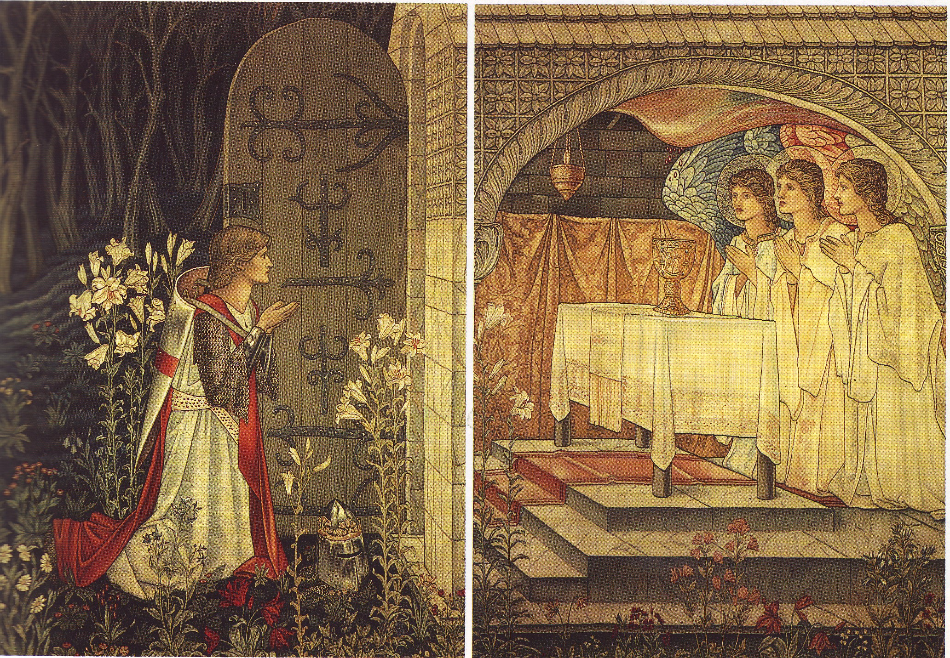

- To be or not to be
When a man discovers chivalry, he must take it upon himself to decide if he has the interest and commitment to follow the path to knighthood. It is something to be seriously pondered for it is a commitment for life. Chivalry and its virtues need to be recaptured from the halls of history and be put to good use in his daily life. Chivalry can help him not only instill values in himself, but he can pass them on to his children. It can change the way he manages others and does business. And help him to establish goals and overcome challenges, and most importantly, give him the sense of living with purpose. Chivalry is about respecting and caring for others and brings balance to the one-sided act of only caring about oneself.

- Extending the hand of brotherhood
When the modern man finds the courage to face his weaknesses and fears, and finally takes the plunge towards the path to knighthood, he must find and – (without haste), carefully choose an association, group or Order that he is comfortable with, and with whom there can be correlation. And when he does, he must do so wholeheartedly.

It is also wise however, to ask many questions about the intended Order or group, its aims, teachings, fees, rules, structure, dress code, activities and the like, before immersing oneself in something one later regrets. For it is to these men, this band of brothers, that he must closely bond and concern himself. They will be his mentors, and assistants, critics and friends in whom he confides and places his trust.

For this reason also, a potential acolyte should be cautious of any organization that readily bestows knighthood on people, and particularly if one only needs to pay “a fee” to become a knight. Chivalry cannot be bought, as it is a priceless gift. A committed Order or association will usually take many months and sometimes years before the honour of knighthood can be bestowed, as they will assure themselves that the new companion or squire is worthy of the honour.

- Knight or Knight Errant
An acolyte must also determine whether he wants to be a member of an Order or remain a free agent. Being a knight of an Order holds no precedence over a knight errant as they are both equally the same.
The difference is up to the individual to decide whether he prefers one-on-one mentorship or prefers the activities, fellowship and team work provided in a group. Irrespective, it is the duty of both the knight and knight errant to pass on the message of chivalry to the uninitiated. The best way to promote chivalry is to live it, as people learn best by example.

If each knight errant only reached one interested person per year for twenty years, and ten of those people became seriously committed to the Quest, chivalry would grow tenfold with each succeeding generation. The Code was not something which was developed overnight and took several centuries for it to be perfected. By the same token it will hopefully not take as long, because of the intervention of information technology, and easy access to the new global village, computers and the internet.

The ordered knight can contribute in a more visible way by assisting through community service on behalf of his Order. Providing lectures and workshops and even just setting the example of exemplary living for others to take note of, so that they eventually respect and look up to him. In this the knight must also shoulder his or her responsibility as a community leader to speak for and defend the interests of those who may need assistance.

- Conduct in Public Life
When one determines to live a moral life with high values to aspire to, one becomes the focus of attention of their family and community, who very often, are simply waiting for the first mistake or big fall to quickly say, “See I told you so!”, and thereby possibly justify their own lack of staying power or moral fibre, by saying the road to decency is too difficult. Beware of those who will also try and ensnare you deliberately out of jealousy or vindictiveness, who will delight in setting you up for the fall. For this particular reason, it becomes important for the knight to conduct himself with care in the eyes of the public.

This Quest we set ourselves on is not easy, as we are after all human, and are guaranteed to make mistakes. Generally the wise knight will avoid scandal wherever possible and be on the lookout for snares that may be deliberately set up to trap him on points of public contention. He should adopt the view that his personal opinions are his own and private, and not significant to the cause of chivalry.

Since you will be watched, as it becomes known of your Quest, and association with like-minded people, so it too becomes important to ensure that the kind of people you socialize with are suitable. Not in a snobbish, “I’m better then you” way, but because “birds of a feather flock together”, so to be seen with people who are always drunk or are a nuisance or inconsiderate to their neighbors, pretty soon reflects on you, and creates the wrong impression of your organization as well.

- Conduct in Private
When we deal with our wives and children it must always be with courtesy and respect. It is important that we make sure that we fully understand the concepts of virtue and what each one entails. For it is the virtues which need to be taught, most importantly to our children. It will probably be the greatest gift we can give them as parents. And the best way to do this would be by example. Discipline is also essential in the home and must not be understood as punishment, for punishment is the consequence of poor discipline, just as reward is the consequence of good discipline. With children it is also important to always be consistent in applying discipline as they attempt to test the boundaries. No is always … No!

But to do that, we need to infuse discipline in ourselves, as we need to lead by example so the discipline we wish to instill in our children needs to emanate from our own discipline. Children watch us a lot more closely then we realize and become the mirror image of our thoughts and actions.

We cannot get respect if we do not give it, it’s the principle of reaping what we sow. In the same way we cannot expect love from our spouse, if we do not give it to them also. A relationship cannot be based on fifty-fifty. It is rather one hundred percent both ways. True love (the greatest virtue) is unconditional, and without compromise. As men we need to ensure that we treat our lady like the queen that she should be, which brings us to our next point.

- The Modern Role of Courtly Love
Courtly love was originally the idolization of the loved one by the lover. The lover (idolizer) accepted the independence of his lady love, and made himself worthy of her by acting in a noble fashion and by doing whatever deeds she desired. The relationship had certain rules, similar to the vows exchanged during a wedding ceremony. The knight pledged certain things to the lady. He was expected to woo, or pursue, her, which is the source of our modern courtship behavior. It evolved into such courtesies and gallantries as opening doors, writing poetry, observing formal manners, and asking for a lady's hand on bended knee. Women were treated with honor, not as property.

Many a woman complains today that the man she thought was her knight in shining armour turns out to be the proverbial bullfrog instead. When we first start dating it is always exciting and we often vaguely remember a couple of chivalrous actions such as pulling out her chair, or opening the door, little things that make her feel special. Once married, it seems all of that goes out the window. It is time we men, we gallant knights in shining armour, see our womenfolk a little differently and not always take them for granted.

It is time to charge into the nearest library or bookstore and read up a little on what women want. Yep, not all the answers are found in books, but it is a great starting point to make a few changes. Nothing turns a woman on more than being made to feel special and to be pampered by her man, who takes his time in ensuring her wellbeing and contentment.

- Chivalry in Society, the Workplace and Business Affairs
Modern knights with nine-to-five jobs may not be covered in sweat and gore, but they can and still are knights in shining armor. Chivalry is more than bravado, strength and daring-do; it is also found in those who respect the law, honor their commitments and refuse to compromise their high ethical standards — even when nobody else is watching.
The Code of Chivalry is often difficult and inconvenient to follow in the workplace, but the virtues of knighthood such as honesty, perseverance and fairness can sometimes be vital to an arduous situation. There are always people who depend on you to be industrious, attentive and honest in what you do. People from all walks of life would take comfort in knowing that their chivalrous knight will keep them safe and secure with their lives and possessions. Whether he is a doctor, waiter, social worker or air force pilot. A man whose greatest reward is knowing that he helped someone without that person necessarily even being aware of it.
To follow the Code of Chivalry is often a hindrance when one is called to compromise one’s high morals and ethical standards; it is like going into battle with one hand tied behind your back. “When you’re in fierce, spirited competition, a sense of honor becomes a very palpable

hindrance — a small, fragile roadblock placed in front of a very short and easy path to success”.
- Faith, Religion and the modern Knight
A man’s faith in whatever he believes is his grounding, as long as his belief holds substance. The cornerstone of many religions, in some form or another, has always been chivalric in nature. It is as fundamental as knowing right from wrong, not as we later perceive it, or very often are conditioned to perceive it. But even young children can often sense when they do wrong, or when wrong is done to them.

For many men and women chivalry is part and parcel of their religion, and must therefore be honoured as part of their faith. Others yet, see no need for religion but can still identify with the warm cloak of chivalry. It has been conjectured that it may even predate most if not all religions and that is quite feasible. The point though, is that regardless of our connection with or without religion, we must identify the chivalric nature of the next man, regardless of his personal belief and how much it may differ from our own.

One of the hardest things to do is for one person not to be tempted into converting his fellow men to his way of seeing things, or to respect the opinions of others. We are all tempted to believe that we are right and that everyone else is wrong! This leads to dissension and division and very often open conflict. Our focus should rather be on the good qualities demonstrated in our fellow men and women, and to build on those. This then would be a greater and higher call to faith, when different people can live and work together in perfect harmony, in spite of their religious or other differences.

- Appearance and Wellbeing
His appearance is clean and neat at all times and his attire simple and modest, not ostentatious or loud - as people sum him up initially on appearance - and first impressions are always the lasting ones. He has to be constantly vigilant that he is not seduced by the things around him, both tangible and intangible. He must project confidence, for every knight is and should be a leader for those not familiar with the Quest. People only follow a leader that is sure of his course. He is not necessarily a physically tall, well built, fighting machine, but he may be an intellectual giant.

All knights stand straight up and they walk with confidence. He is not an overbearing bombastic, person, but he also will not allow the uninitiated (that is, people not on the Quest) to assert dominance over him, or those he wishes to protect.

He speaks his truth quietly and honestly, is observant for the opportunity to do good, fair and tactful and is humble in all things. Since we all start this quest with vices, he will start with many - but he should identify and aim to overcome them. However in saying that, a knight should not be an alcoholic or drug dependent, nor should he be involved in any other vice that would be damaging to the cause of chivalry, if it was public knowledge (and therefore visible to others such as membership of racist/sexist groups), as this can create a misconception of what the Quest is all about.

These more serious weaknesses should be attended to before he can be admitted to an association or Order. There are other “lesser” vices that are not easily seen, or are less “damaging” and that need to be dealt with as we proceed on our path, such as overeating,

family abuse, theft, anger management, etc. This is important as this can present a wrong image of our life’s mission. Vices are weaknesses that will detract us from our Quest, so they need to be dealt with as a condition of membership, albeit progressively over time. It is after all a lifetime quest!

It is advisable to also brush up on rules of etiquette, public speaking and power dressing, to name a few image builders. There can be nothing more embarrassing then not knowing which knife and fork to use with which course, or whether we can eat hamburgers with napkins or knife and fork. How does one address the local bishop, president or some other dignitary correctly? As a knight the public would expect him to know the social graces as part of his role as a knight in modern society – at the very least!



